D206 Performance Assessment
Western Governors university
Jeremiah Murray

Part I: Research Question:
- Research Question
- Is there a correlation between area type and the number of outage seconds leading to more customer churn?
- Description of Variables
Variable | Data Type | Description | Example
Case Order | Qualitative | Placeholder to preserve order of raw data file | 25
Customer_id | Qualitative | Unique ID for each customer | B248010
Interaction | Qualitative | IDs related to customer transactions | 4762-8f35-e676fbefb689
City | Qualitative | Customer city of residence | Harrisburg
State | Qualitative | Customer state of residence | WV
County | Qualitative | Customer county of residence | Marion
Zip | Qualitative | Customer zip code of residence | 54732
Lat | Qualitative | Latitudinal coordinates of residence. | 41.92683
Lng | Qualitative | Longitudinal coordinates of residence | -82.16361
Population | Quantitative | Population of residence area | 379
Area | Qualitative | Type of residential are (urban, suburban, rural) | Rural
Timezone | Qualitative | Time zone of customer residence. | America/Denver
Job | Qualitative | Occupation of customer | Sports Coach
Children | Quantitative | Customer number of children | 7
Age | Quantitative | Age of customer | 21
Education | Qualitative | Customer education level | Master’s Degree
Employment | Qualitative | Customer employment status | Unemployed
Income | Quantitative | Customer yearly salary | 12002.38
Marital | Qualitative | Customer marital status | Married
Gender | Qualitative | Customer gender | Female
Churn | Qualitative | Whether or not customer has discontinued services | No
Outage_sec_perweek | Quantitative | Average amount of seconds per week of system outages in a customer’s neighborhood | 16.9996509
Email | Quantitative | Number of emails sent to the customer within the last year | 16
Contacts | Quantitative | Number of times customer contacted customer support | 2
Yearly_equip_failure | Quantitative | Number of times customer experienced equipment failure within past year | 0
Techie | Qualitative | Whether or not customer considers themselves technically inclined | Yes
Contract | Qualitative | Customer contract term | One year
Port_modem | Qualitative | Whether or not customer has portable modem | No
Tablet | Qualitative | Whether customer owns tablet | Yes
InternetService | Qualitative | Customer Internet service provider | FiberOptic
Phone | Qualitative | Whether customer has phone service | Yes
Multiple | Qualitative | Whether customer has multiple lines | No
OnlineSecurity | Qualitative | Whether customer added online security | Yes
OnlineBackup | Qualitative | Whether customer added online backup service | Yes
DeviceProtection | Qualitative | Whether customer added device protection | No
TechSupport | Qualitative | Whether customer added tech support service | No
StreamingTV | Qualitative | Whether customer has TV streaming | Yes
StreamingMovies | Qualitative | Whether customer has movie streaming | No
PaperlessBilling | Qualitative | Whether customer uses paperless billing | Yes
PaymentMethod | Qualitative | Customer payment method | Credit Card (automatic)
Tenure | Quantitative | Number of months customer has stayed with provider | 58.86869
MonthlyCharge | Quantitative | Average amount charged to the customer per month | 91.61045708
Bandwidth_GB_Year | Quantitative | Average amount of date used, in gigabytes, per year | 6066.504
 |  | The following variables are responses to an 8-question survey asking customers to rate the importance of various factors | 1 = most important  8 = least important
Item1 | Qualitative | Timely response | 3
Item2 | Qualitative | Timely fixes | 4
Item3 | Qualitative | Timely replacements | 3
Item4 | Qualitative | Reliability | 2
Item5 | Qualitative | Options | 5
Item6 | Qualitative | Respectful response | 1
Item7 | Qualitative | Courteous exchange | 8
Item8 | Qualitative | Evidence of active listening | 6

Part II: Data Cleaning Plan
B1: Cleaning Plan
The first step was to import the CSV file. Once that was done, I used the df.info() function to determine each variable's data type. This is necessary because certain functions only work on certain data types. Once the different data types are understood, the following techniques will be used:
- Duplicate values will be identified with the df.duplicated function. If any duplicates are discovered, they will be removed using the df.drop_duplicates function.
- Checking for missing values with functions like df.isnull(). If missing values are found, a decision will be made to impute or drop rows and columns with too many missing values.
- Outliers will be detected using the IQR (interquartile range). Based on which categories have outliers present and how many there are, I will determine how to handle them, or if they need to be handled at all.
- Qualitative data will be converted to numerical data when necessary.
- Visualizations such as charts, graphs, and plots will be used throughout as a way to easily verify that all cleaning steps were done correctly.
B2: Justification of Approach
The churn data set has quantitative variables (Income, Tenure, Emails, etc.) and qualitative variables (Education, Gender, Marital, etc.). The approaches outlined in my plan can identify and handle common issues that could skew the analysis. Duplicated data can cause the data to be misinterpreted. Missing data can cause further misrepresentation. Using imputation to fill in missing data can ensure that the data being analyzed is more complete and bias is minimized. Detection of outliers can allow us to determine if they may lead to any distortion of measurements. We can ensure that our data is ready for accurate analysis by handling these issues.
B3: Justification of Tools
Python was used for its access to a wide range of libraries and extensive support of data manipulation. The pandas library in particular is useful for handling missing values and transforming data. The numpy library was imported for its use in numerical computation. The matplotlib library was also imported, as it allows the use of data visualization tools such as histograms and box plots. Python is one of the most widely used programs in the world of data analysis and learning how to use it for this important step in the data analytic life cycle will be extremely beneficial.
Part III: Data Cleaning
C1: Description of Findings
The first step was to determine all of the data types present in the data set. This was accomplished with the df.info() function. The data types present were as follows:
<class 'pandas.core.frame.DataFrame'>
RangeIndex: 10000 entries, 0 to 9999
Data columns (total 52 columns):
# Column Non-Null Count Dtype
--- ------ -------------- -----
0 Unnamed: 0 10000 non-null int64
1 CaseOrder 10000 non-null int64
2 Customer_id 10000 non-null object
3 Interaction 10000 non-null object
4 City 10000 non-null object
5 State 10000 non-null object
6 County 10000 non-null object
7 Zip 10000 non-null int64
8 Lat 10000 non-null float64
9 Lng 10000 non-null float64
10 Population 10000 non-null int64
11 Area 10000 non-null object
12 Timezone 10000 non-null object
13 Job 10000 non-null object
14 Children 7505 non-null float64
15 Age 7525 non-null float64
16 Education 10000 non-null object
17 Employment 10000 non-null object
18 Income 7510 non-null float64
19 Marital 10000 non-null object
20 Gender 10000 non-null object
21 Churn 10000 non-null object
22 Outage_sec_perweek 10000 non-null float64
23 Email 10000 non-null int64
24 Contacts 10000 non-null int64
25 Yearly_equip_failure 10000 non-null int64
26 Techie 7523 non-null object
27 Contract 10000 non-null object
28 Port_modem 10000 non-null object
29 Tablet 10000 non-null object
30 InternetService 7871 non-null object
31 Phone 8974 non-null object
32 Multiple 10000 non-null object
33 OnlineSecurity 10000 non-null object
34 OnlineBackup 10000 non-null object
35 DeviceProtection 10000 non-null object
36 TechSupport 9009 non-null object
37 StreamingTV 10000 non-null object
38 StreamingMovies 10000 non-null object
39 PaperlessBilling 10000 non-null object
40 PaymentMethod 10000 non-null object
41 Tenure 9069 non-null float64
42 MonthlyCharge 10000 non-null float64
43 Bandwidth_GB_Year 8979 non-null float64
44 item1 10000 non-null int64
45 item2 10000 non-null int64
46 item3 10000 non-null int64
47 item4 10000 non-null int64
48 item5 10000 non-null int64
49 item6 10000 non-null int64
50 item7 10000 non-null int64
51 item8 10000 non-null int64
dtypes: float64(9), int64(15), object(28)

Knowing which data type is associated with each column is important, as different data types handle missing values in different ways. The df.duplicated() function was used to determine if there were any duplicate values in any columns. The results were as follows:
0 False
1 False
2 False
3 False
4 False
...
9995 False
9996 False
9997 False
9998 False
9999 False
Length: 10000, dtype: bool

For further confirmation, I used print(df.duplicated().value_counts()) to count any duplicate values. This function returned the output “False 10000”, meaning that there were no duplicate values in any of the columns. Had any duplicate values been discovered, they would’ve been dropped using the df.drop_duplicates() function.
Missing values were detected using the df.isnull().sum()function. The results were as follows:
CaseOrder 0
Customer_id 0
Interaction 0
City 0
State 0
County 0
Zip 0
Lat 0
Lng 0
Population 0
Area 0
Timezone 0
Job 0
Children 2495
Age 2475
Education 0
Employment 0
Income 2490
Marital 0
Gender 0
Churn 0
Outage_sec_perweek 0
Email 0
Contacts 0
Yearly_equip_failure 0
Techie 2477
Contract 0
Port_modem 0
Tablet 0
InternetService 2129
Phone 1026
Multiple 0
OnlineSecurity 0
OnlineBackup 0
DeviceProtection 0
TechSupport 991
StreamingTV 0
StreamingMovies 0
PaperlessBilling 0
PaymentMethod 0
Tenure 931
MonthlyCharge 0
Bandwidth_GB_Year 1021
item1 0
item2 0
item3 0
item4 0
item5 0
item6 0
item7 0
item8 0
dtype: int64

Outliers were detected using box plots and IQR (interquartile range). To save time, a function was used to generate a box plot for every numerical category all at once, instead of generating an individual box plot for each variable one by one. Once the outliers were visualized, the IQR was calculated for each numeric variable, then the lower and upper bounds were calculated. A dictionary was created using outliers_dict = {}, so the outlier could be stored and easily counted. Once these steps were completed, a function was used to print out the number of outliers detected for each variable.
The number of outliers for each variable was as follows:
print(outliers_dict)
{'Lat': 158, 'Lng': 273, 'Population': 937, 'Children': 451, 'Income': 759, 'Outage_sec_perweek': 539, 'Email': 38, 'Contacts': 8, 'Yearly_equip_failure': 94, 'Techie': 1257, 'Phone': 846, 'MonthlyCharge': 5, 'item1': 442, 'item2': 445, 'item3': 418, 'item4': 433, 'item5': 422, 'item6': 413, 'item7': 454, 'item8': 426}

C2: Justification of Mitigation Methods
There were no duplicate data values, so there was no need to treat for this. To handle missing values, statistical imputation methods were used. First, certain categorical variables had to be changed into numerical values. These variables were ‘Techie’, ‘InternetService’, ‘Phone’, and ‘TechSupport’. Histograms were then generated for each variable to visualize how the missing values were affecting them. Statistical imputation is essentially using he mean, median, or mode to fill in missing values. Imputation was chosen over just dropping missing data to preserve data quantity and preserve any relationships that might exist between certain values.
The median was used to impute variables that were skewed towards one direction. Using the mean to impute is best for variables where the data is evenly distributed, and the mode is best used for categorical variables. For example, the function used to impute using the median would be df['Children'].fillna(df['Children'].median(), inplace=True) (KumarI, 2023). You would simply change the word “median” in the function to either “mode” or “mean” for the other methods. (KumarI, 2023)
Box plots and IQR were used to discover outliers. The IQR identifies values that are outside of the standard range of the data by calculating the upper and lower bounds of a variable. A loop was used to calculate the IQR and upper/lower bounds for all numerical categories at once.
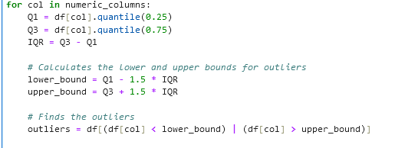 (Pierre, 2022)
The decision was made to leave the outliers in. When analyzing churn data, outliers may provide critical information, and removing them can be a detriment to analysis. In categories like Income and Population, especially, outliers can end up being a natural part of the data. Their removal can introduce bias, misrepresent real-world conditions, and eliminate information relevant to certain subgroups.

C3: Summary of Outcomes
To get a better picture of the dataset, visualizations were used. Visualization can allow one to pinpoint trends or patterns in data. Once these patterns are identified, mitigation techniques can be applied. Missing data was visualized with a matrix. The msno.matrix(df) function was used to generate a matrix that shows exactly where there is missing data. The same function could be used after treating the missing data to confirm that there were no more gaps in the dataset. Below is the visualization matrix before and after the treatment of missing data.

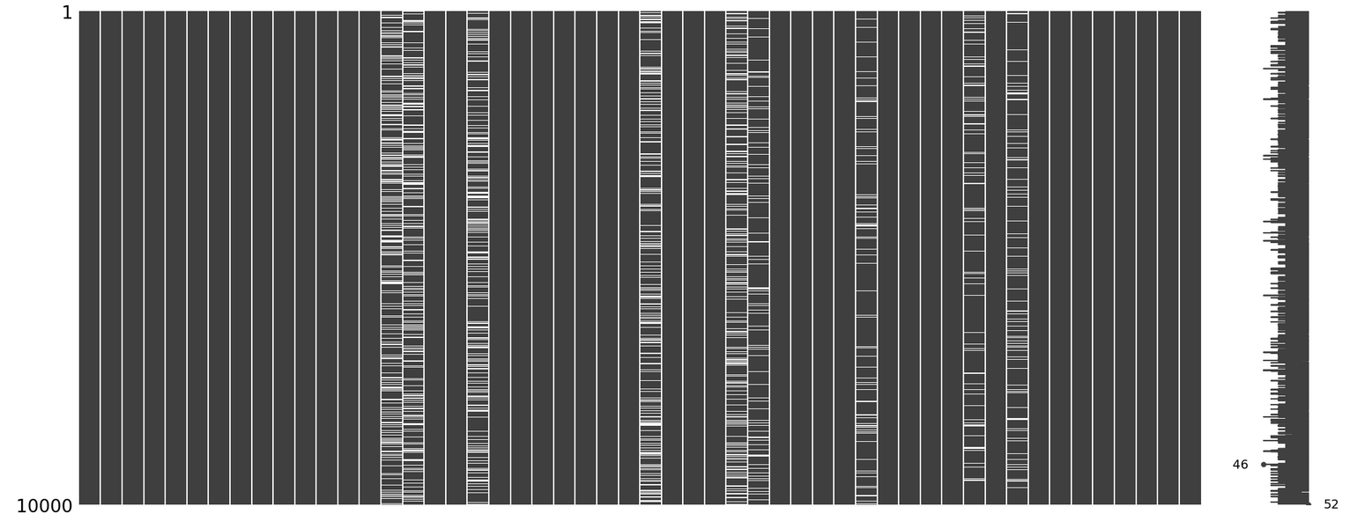

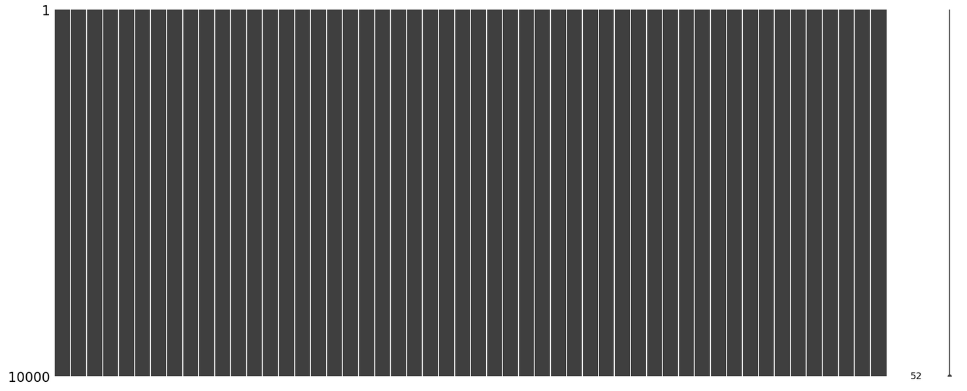

The missing data was treated by replacing it using imputation methods. Histograms were used to visualize the variable before and after treatment. For example, here is the histogram for the ‘Children’ variable before and after the median was used to impute the data:
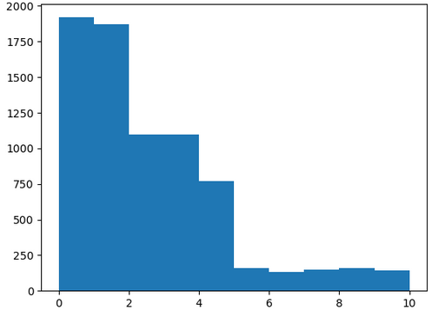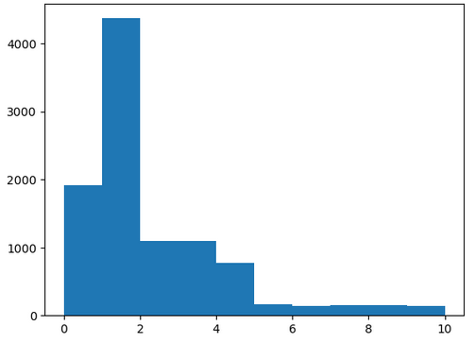

To discover outliers in the data set, they were visualized using a boxplot. To save time, a boxplot was generated for each numerical variable at once using the following function:
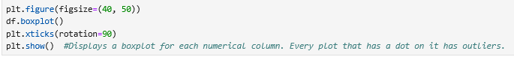
This was the resulting visualization:
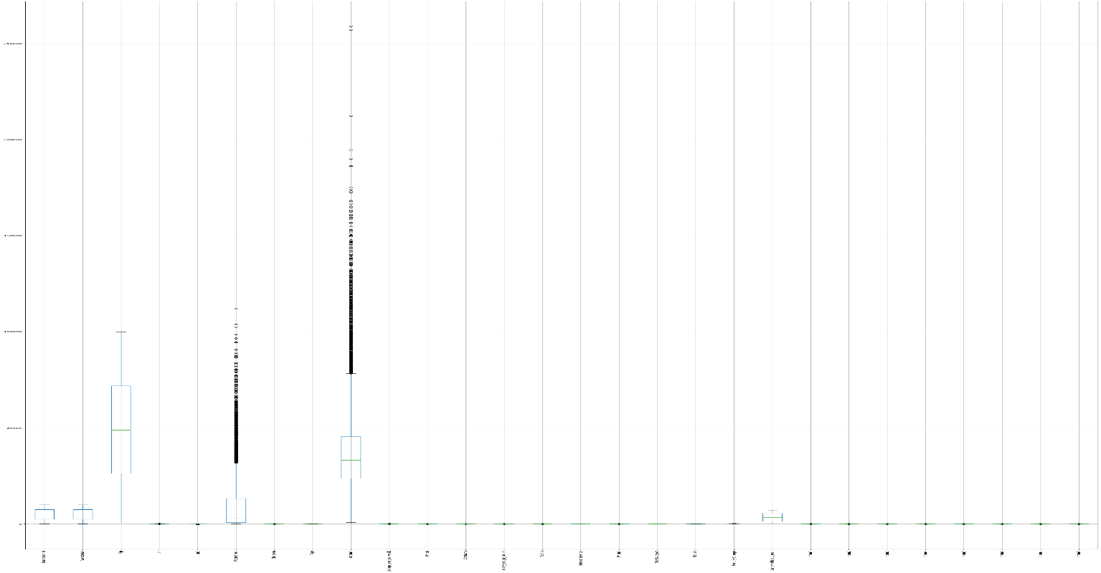
Once the boxplots were created, the number of outliers in each column was calculated using the IQR, and the results were as follows:
print(outliers_dict)
{'Lat': 158, 'Lng': 273, 'Population': 937, 'Children': 451, 'Income': 759, 'Outage_sec_perweek': 539, 'Email': 38, 'Contacts': 8, 'Yearly_equip_failure': 94, 'Techie': 1257, 'Phone': 846, 'MonthlyCharge': 5, 'item1': 442, 'item2': 445, 'item3': 418, 'item4': 433, 'item5': 422, 'item6': 413, 'item7': 454, 'item8': 426}
As stated earlier, the decision was made to leave outliers in, as they can provide valuable insight into the dataset.
C4. Limitations of data cleaning
A significant limiting factor of data cleaning is subjectivity. How to handle data that needs to be cleaned is ultimately up to whoever is cleaning it. Additionally, what is considered an error or even an outlier is dependent on context. One analyst may decide that outliers need to be removed, while another analyst may decide that the outliers are statistically important to the dataset. Another thing is the cost. Data cleaning is something that needs to be performed regularly, and it requires someone skilled in the necessary programming languages. Data cleaning requires a significant time investment and is also extremely resource-intensive, especially for large data sets such as these. Furthermore, if the data isn’t properly cleaned, this can lead to other complications, such as bias in the dataset or erroneous data that renders the dataset unusable. (Data Cleaning, n.d.)
C5. The Effects of limitations on the research question
The choices made throughout the data cleaning process can have a significant effect on my research question, which asks, “Is there a correlation between area type and the number of outage seconds leading to more customer churn?” If the cleaning methods are improper or incomplete, the results can be significantly distorted. For instance, if a large number of records with missing values are removed or even imputed incorrectly, it can obscure patterns or introduce biases. Additionally, if outliers are mishandled, such as removing high outage durations without considering their contextual significance, it can lead to the exclusion of legitimate cases.
E1. PCA
The total number of principal components returned is 7. The output of the loading matrix is as follows:
Principal Component Loading Matrix:
PC1 PC2 PC3 PC4 PC5 \
Population 0.000086 -0.062190 -0.660547 -0.275819 0.695453
Income 0.006007 -0.001259 0.118452 0.877736 0.459675
Outage_sec_perweek 0.022535 0.705442 -0.000303 0.012698 0.076849
Yearly_equip_failure 0.015689 0.065113 0.730511 -0.391584 0.542854
Tenure 0.705253 -0.058468 -0.001226 0.001768 -0.005823
MonthlyCharge 0.045616 0.700505 -0.126249 0.000834 -0.065898
Bandwidth_GB_Year 0.706929 -0.010787 -0.007759 -0.000957 -0.008426

PC6 PC7
Population -0.008909 -0.000506
Income -0.064880 0.000940
Outage_sec_perweek 0.704114 0.000031
Yearly_equip_failure -0.117611 -0.002552
Tenure 0.036641 -0.705563
MonthlyCharge -0.696162 -0.047839
Bandwidth_GB_Year -0.010915 0.707025

E2. Justification of the reduced number of principal components
The application of Principal Component Analysis (PCA) reduced the number of components based on the amount of variance each component explained. The first few principal components account for the majority of total variance, while the remaining components return diminishing values. By retaining the components that capture around 90% of the cumulative variance, the dataset was significantly simplified.

E3. Benefits of PCA
Principal component analysis would allow the organization to reduce data dimensionality without sacrificing key information. It essentially makes datasets easier to analyze and interpret. Extracting only the most important and informative features of large datasets would allow the organization to more easily identify patterns and improve the overall efficiency of analysis. (IBM, 2023)

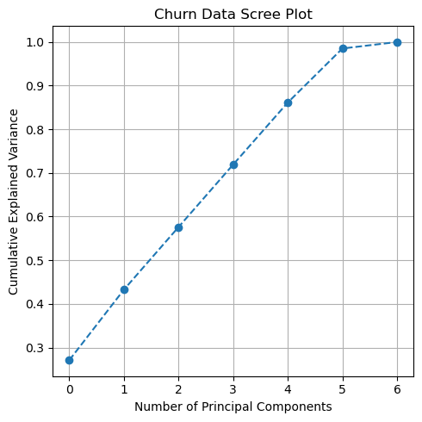

G. Citations

- KumarI , A. (2023, December 18). Python - replace missing values with mean, median & mode. Analytics Yogi. https://vitalflux.com/pandas-impute-missing-values-mean-median-mode/

- Pierre, S. (2022, April 27). How to find outliers (with examples). Built In. https://builtin.com/data-science/how-find-outliers-examples#:~:text=Using%20IQR%20to%20detect%20outliers,minus%201.5%20times%20the%20IQR.

- IBM. (2023, December 8). What is principal component analysis (PCA)? Ibm.com. https://www.ibm.com/think/topics/principal-component-analysis

- ‌PCA in Python Tutorial with Scikit-Learn | Built In. (n.d.). Builtin.com. https://builtin.com/machine-learning/pca-in-python

- ‌Data Cleaning. (n.d.). Validity. https://www.validity.com/data-quality/data-cleaning/

